BPMN Diagrams
UC01: Create a personal checking account

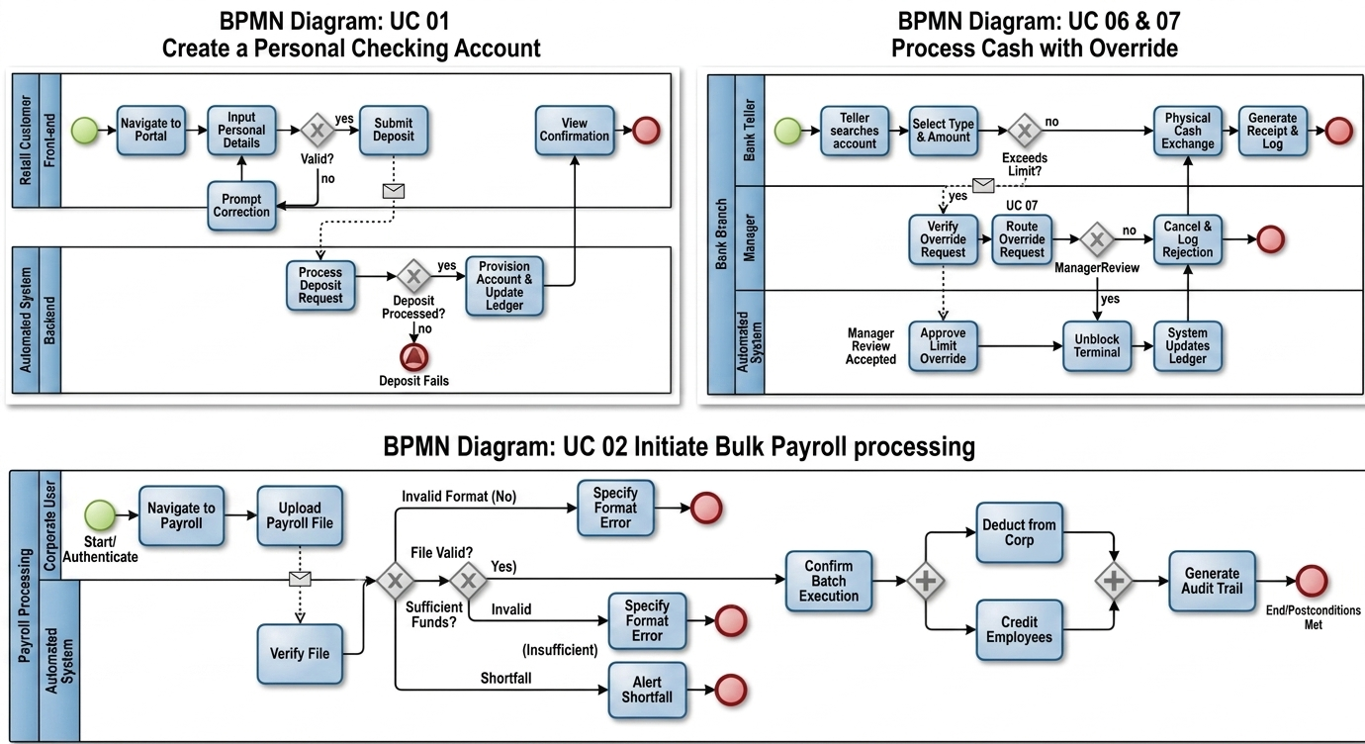

UC02: Initiate Bulk Payroll Processing



UC06 and UC07: Process cash with override



